FRDM K64 - Uart Test

In this example we will send and receive structure from Windows C# application to K64 Uart interface

Sources:

Start from Kinetis design studio 3.2 , UART polling example from the FRDM k64 Sdk

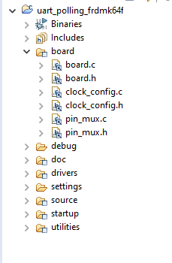

The example use UART0

PORT_SetPinMux(PORTB, PIN16_IDX, *kPORT_MuxAlt3*); /* PORTB16 (pin E10) is configured as UART0_RX */

PORT_SetPinMux(PORTB, PIN17_IDX, *kPORT_MuxAlt3*); /* PORTB17 (pin E9) is configured as UART0_TX */

The problem is that PTB16 and PTB17 are not output in the FRDM k64

We will use UART1 TX And RX

K64 datasheet:

<https://www.nxp.com/docs/en/data-sheet/K64P144M120SF5.pdf>

k64 frdm schematic:

FRDM-K64F-SCH-E4.pdf

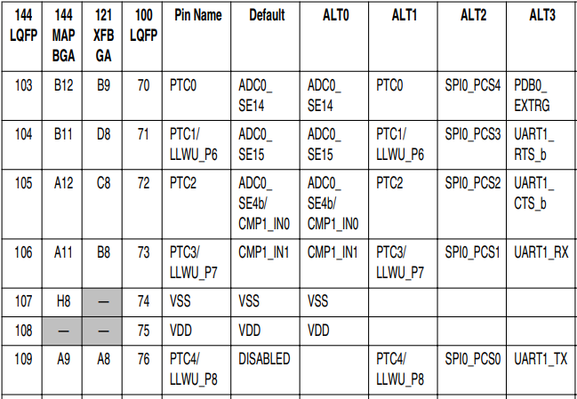

From the K64 datasheet we learn that

PTC3 is UART1_RX at pin mux ALT3

PTC4 is UART1_TX at pin mux ALT3

Let’s add in the pin_mux.c the following:

**void** **BOARD_InitPins**(**void**)

{

CLOCK_EnableClock(*kCLOCK_PortB*); /* Port B Clock Gate

CLOCK_EnableClock(*kCLOCK_PortC*); Control: Clock enabled */

PORT_SetPinMux(PORTB, PIN16_IDX, *kPORT_MuxAlt3*); /* PORTB16 (pin E10) is configured as UART0_RX */

PORT_SetPinMux(PORTB, PIN17_IDX, *kPORT_MuxAlt3*); /* PORTB17 (pin E9) is configured as UART0_TX */

PORT_SetPinMux(PORTC, PIN3_IDX, *kPORT_MuxAlt3*); /*configured as UART1_RX*/

PORT_SetPinMux(PORTC, PIN4_IDX, *kPORT_MuxAlt3*); /* configured as UART1_TX*/

SIM->SOPT5 = ((SIM->SOPT5 &

(~(SIM_SOPT5_UART0TXSRC_MASK))) /* Mask bits to zero which are setting */

| SIM_SOPT5_UART0TXSRC(SOPT5_UART0TXSRC_UART_TX) /* UART 0 transmit data source select: UART0_TX pin */

);

}

Connection:

PTC4 located in J2 pin4

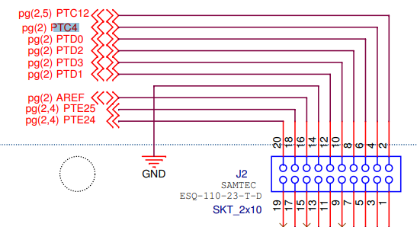

PTC3 located in J1 pin 16:

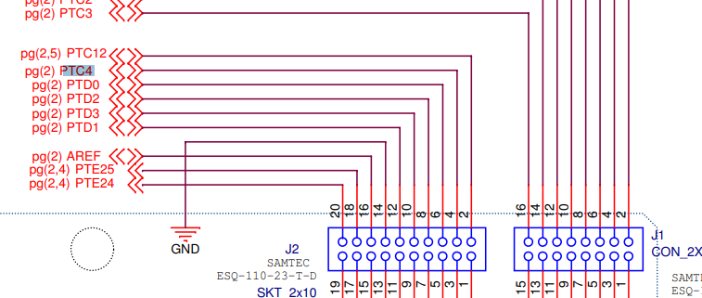

From the PC we are using COM Connector

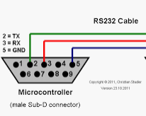

Lets finally connect

Pin 2 in rs232(tx) to j1 pin16(rx)

Pin3 in rs 232(rx) to j2 pin4(tx)

We cross the rx tx

In Kinetis Design studio 3.2 we can make a bin file and use drag and drop , simple copy the bin into the Mbed disk

In settings, toolchanin:

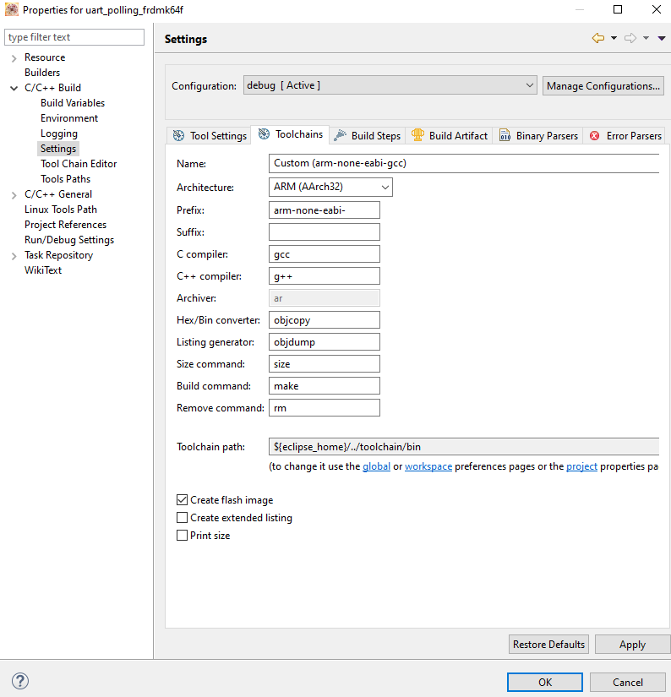

Select create flash image, press ok and open settings again:

In project properties , select raw binary

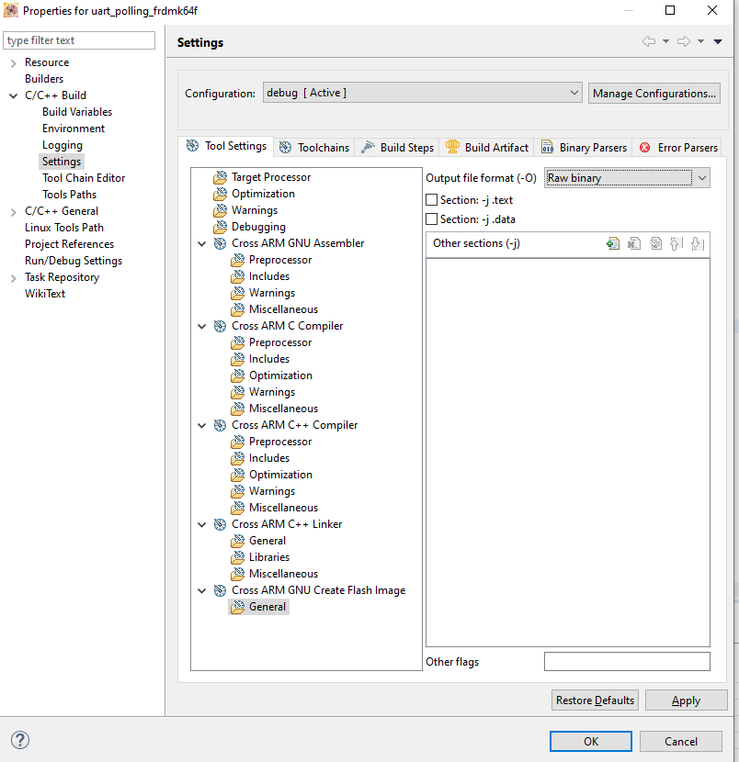

Compile your project , you should now have a bin file in the debug directory

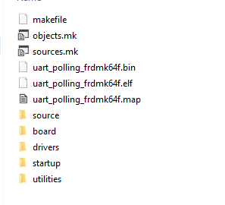

This file need to be copy into the MBED disk

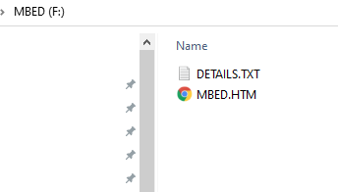

Go to device manager, ports , and find the mbed com port

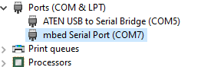

Open terminal, like putty:

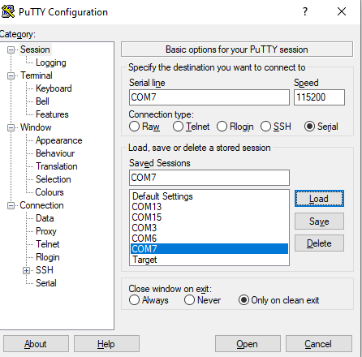

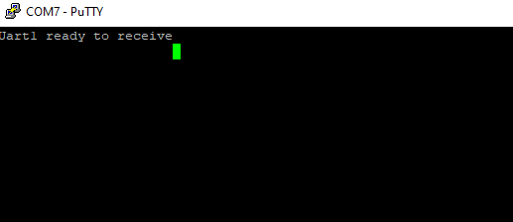

Hey , before we continue , there are some changes that need to be done in the code.

The original sample uses uart0 for communication, we change it to UART1,

We do want to see print in uart0 , so we just need to initialize the debug console:

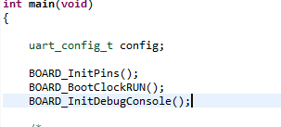

Add BOARD_InitDebugConsole and you will see PRINTF in your putty terminal.

Our code wait for specific structure:

**#pragma** pack(push, 1)

**typedef** **struct** Header

{

uint16_t UartPrefix;

uint16_t opcode;

uint8_t msgSize;

} Header;

**typedef** **struct** MSG1

{

Header header;

uint32_t data;

uint8_t value;

uint16_t value1;

uint16_t crc;

} MSG1;

**typedef** **struct** MSG2

{

Header header;

uint16_t data;

uint8_t value;

uint32_t value1;

uint16_t crc;

} MSG2;

**#pragma** pack(pop)

It is important to make the structure alignment of both compiles , KDS and Visual studio c# on the same packing

We are using 1 byte alignment

We are Initializing UART1 and waiting for this messages from Windows c# application

UART_GetDefaultConfig(&config);

config.baudRate_Bps = BOARD_DEBUG_UART_BAUDRATE;

config.enableTx = true;

config.enableRx = true;

UART_Init(COMM_UART, &config, CLOCK_GetFreq(COMM_UART_CLKSRC));

PRINTF("Uart1 ready to receive\n");

//UART_WriteBlocking(COMM_UART, txbuff, sizeof(txbuff) - 1);

MSG1 msg;

**while** (1)

{

UART_ReadBlocking(COMM_UART, (uint8_t *)&msg, **sizeof**(msg));

PRINTF("UartPrefix 0x%x\n" , msg.header.UartPrefix);

PRINTF("msgSize 0x%x\n" , msg.header.msgSize);

PRINTF("opcode 0x%x\n" , msg.header.opcode);

PRINTF("data 0x%x\n" , msg.data);

PRINTF("value1 0x%x\n" , msg.value);

PRINTF("value1 0x%x\n" , msg.value1);

PRINTF("crc 0x%x\n" , msg.crc);

//UART_WriteBlocking(DEMO_UART, &ch, 1);

}

In Windows PC , we are using ATEN USB



It is COM5.

Now the intersting part of the story here:

The K64 by default send and receive inverted data to host and from host.

For example , 0x1 send is received 0x7f

The K64 have UART internal registers that can be found detaild in the K64 reference manual

By looking in the reference manual

We see two regisrers TXINV and RXINV

**typedef** **union** _hw_uart_s2

{

uint8_t U;

**struct** _hw_uart_s2_bitfields

{

uint8_t RAF : 1; /*!< [0] Receiver Active Flag */

uint8_t LBKDE : 1; /*!< [1] LIN Break Detection Enable */

uint8_t BRK13 : 1; /*!< [2] Break Transmit Character Length */

uint8_t RWUID : 1; /*!< [3] Receive Wakeup Idle Detect */

uint8_t RXINV : 1; /*!< [4] Receive Data Inversion */

uint8_t MSBF : 1; /*!< [5] Most Significant Bit First */

uint8_t RXEDGIF : 1; /*!< [6] RxD Pin Active Edge Interrupt Flag */

uint8_t LBKDIF : 1; /*!< [7] LIN Break Detect Interrupt Flag */

} B;

} hw_uart_s2_t;

hw_uart_s2_t S2;

S2.U = UART_ReadS2(COMM_UART);

PRINTF("S2: 0x%x\n", S2.U);

PRINTF("RXINV: %d\n", S2.B.RXINV);

PRINTF("MSBF: %d\n", S2.B.MSBF);

S2.B.RXINV = 1;

S2.B.MSBF = 0;

UART_WriteS2(COMM_UART,S2.U);

S2.U = UART_ReadS2(COMM_UART);

PRINTF("S2: 0x%x\n", S2.U);

PRINTF("RXINV: %d\n", S2.B.RXINV);

PRINTF("MSBF: %d\n", S2.B.MSBF);

uint8_t C1 = UART_ReadC1(COMM_UART);

PRINTF("C1: 0x%x\n", C1);

uint8_t C3 = UART_ReadC3(COMM_UART);

PRINTF("C3: 0x%x\n", C3);

C3 = C3 | 0x10;

UART_WriteC3(COMM_UART, C3);

The code here put 1 in both:

By doing so the data is now inverted right.

Another problem ( not yet solved ) is that the TX fifo on the startup , from k64 to host , send first zero before data.

Another concolusion is that the endianes is kept the same from k64 and Windows Host.

EDMA Example

Load the dma example , and lets do the same , send and receive data from out c# host application

Mofified quicly the same change to move to UART1

pin_mux.c

**void** **BOARD_InitPins**(**void**)

{

CLOCK_EnableClock(*kCLOCK_PortB*); /* Port B Clock Gate Control: Clock enabled */

CLOCK_EnableClock(*kCLOCK_PortC*);

PORT_SetPinMux(PORTB, PIN16_IDX, *kPORT_MuxAlt3*); /* PORTB16 (pin E10) is configured as UART0_RX */

PORT_SetPinMux(PORTB, PIN17_IDX, *kPORT_MuxAlt3*); /* PORTB17 (pin E9) is configured as UART0_TX */

PORT_SetPinMux(PORTC, PIN3_IDX, *kPORT_MuxAlt3*); /* UART1_RX */

PORT_SetPinMux(PORTC, PIN4_IDX, *kPORT_MuxAlt3*); /* UART1_TX */

SIM->SOPT5 = ((SIM->SOPT5 &

(~(SIM_SOPT5_UART0TXSRC_MASK))) /* Mask bits to zero which are setting */

| SIM_SOPT5_UART0TXSRC(SOPT5_UART0TXSRC_UART_TX) /* UART 0 transmit data source select: UART0_TX pin */

);

}

In Main add the debug console to see PRINTF

BOARD_InitPins();

BOARD_BootClockRUN();

BOARD_InitDebugConsole();

The EDMA shows the same problem

1. Data is inverted
2. First TX is zero